TMT/Pondy Oxdies /S0706/2026 11-03-2026

To,
Pondy Oxides & Chemicals ltd,
Mobile: 9789465325.
Chittoor Dist, AP.

Dear Sir,
SUB :- SUPPLY OF Scrap Bailing press SMALL SIZE

We thank you for your inquiry regarding Bailing press for scrap 2000x3mm. We are glad to inform you that we would be in a position to do the required equipment. Given below are the specifications and description of the machines and our terms and conditions.

Models | Small size
Bailing chamber | 20”20”50”
Bail size | 10”x10”x8-10”
Weight of bail | 45 kg
Body | MS fabricated steel Structure
Pump | High pressure double vane pump
Cover ram tonnage | 45
main ram tonnage | 65
Side ram tonnage | 90
Ejector tonnage | 6-2 no’s
Power | 20 hp
Price | 9 Lakhs

GENERAL TERMS & CONDITIONS:

1. Price quoted per unit ex-work. Hyderabad.
- Following charges are additional to your account.
  - Freight Charge : As actual to be borne by you.
  - Sales Tax : 18% Extra as applicable
  - Packing charge : As actual to be borne by you.
  - Insurance : As actual to be borne by you.
- Payment : 75% advance along with order balance before delivery but after inspection at our works.
- Delivery : with 75% advance 1month / With 50% advance 2 months / With 30% - 4 months from date of advance received
- Validity : One month from the date of submission.
- Inspection : Inspection at our works prior to dispatch.
- Warranty : The machine is warranted for a period of 12 months from the date of dispatch against any manufacturing defects/ faulty material or bad workmanship of any part or component but not against any kind of abnormal or improper use of machine. Defective part or component will be replaced or repaired free of cost. Electrical components are outside the scope of this warranty.
- Commissioning : Erection & commissioning done by you, but required technical support & guidance provide by us at additional cost.

NOTE:
- Oil is not in scope of our supply.
- Raw material for trial is to be arranged by you at your cost.

We are sure you will find our offer in line with your requirements. Should you require any further clarification please contact 9246221106

Thanking you and assuring you of our best services

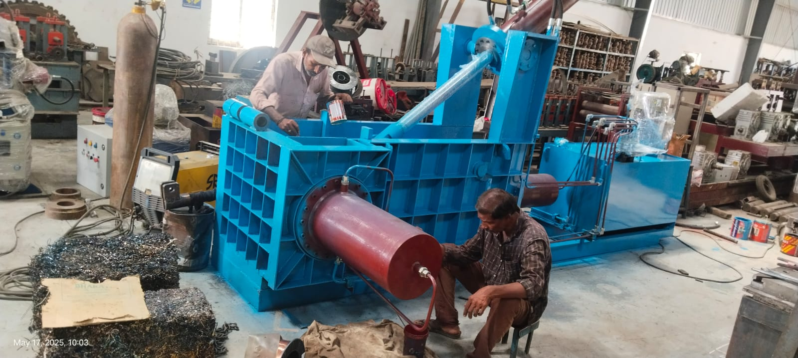

For TECHNO MACHINE TOOLS

(T. SIVARAMAKRISHNA)

Our bank details

Techno Machine Tools
IFSC CODE: PUNB0115310
ACC. NO: 11534015002032

